A 3-DAY WORKSHOP-
STATISTICAL DATA ANALYSIS & REPORTING For Masters and Ph.D THESIS (Advanced level)
All staff from Ministry of Education & Universities
  - Speaker: A. Prof. Dr. Ali Hussein Zolait (PhD, MIS)

Synopsis

Content
Part I. Basic Data Analysis
- Data Processing, Coding & Handling of Missing Values
- Frequency Analysis
- Descriptive Statistics
- Exploratory Data Analysis (EDA)
- Cross-Tabulation Analysis
- Hands-on exercises using SPSS & Reporting

Part II. Comparing Groups
- T-test for two groups (independent & paired)
- Analysis of Variance (ANOVA)
- Hands-on exercises using SPSS & Reporting

Part III. Relationships Analysis
- Correlation Analysis
- Regression Modeling
- Hands-on exercises using SPSS & Reporting

Part IV. Factor Analysis
- Exploratory Factor Analysis (EFA)
- Reliability and Validity Analyses
- Hands-on exercises using SPSS & Reporting

Dates: 10/7-12/7 2013
Or 26 -28 Jan 2014
This workshop is about ‘Statistical Data Analysis’ for candidates preparing for Chapters 4 and 5 of their Masters or PhD thesis. In this workshop we shall guide the participants on the use of proper and standard Statistical Methods for the analysis of data from survey questionnaires and business research. The workshop will discuss both Exploratory and Confirmatory Data Analyses as the standard techniques in data analysis. Statistical software SPSS will be used as a tool for analyzing the data and the participants will engage in ‘hands-on’ activities on the use of the software.
Who Should Attend?
(i) All postgraduate (MBA, PhD etc)
in the fields of Business &
Management, Social Sciences,
Technology, Hospitality & Service
Management etc.
(ii) Researchers who need to enhance their skills in analyzing statistical data
and reporting the results of data analysis.
Formal education and training in Statistics subjects are not required.

By having the required skills for analyzing the data, the participants will be guided on how to communicate and report the results of data analysis in a scholarly and standard manner as normally expected from a Masters or PhD thesis. The statistical reporting will cover all aspects of analyses that would answer all the research questions and objectives as explicitly stated by the research hypotheses.

Participants are required to bring along laptops and with SPSS software, and sample data sets (if available), prior to the workshop. In the workshop, participants will be coached on how to use SPSS in ‘live’ data analysis exercises.
First Day xx/xx/2013
TIME | PROGRAMME
Session I. Basic Data Analysis
- Data Processing, Coding & Handling of Missing Values
- Frequency Analysis
- Descriptive Statistics

 | Tea Break
Session I. Basic Data Analysis
- Exploratory Data Analysis (EDA)
- Cross-Tabulation Analysis
- Hands-on exercises using SPSS & Reporting

 | Lunch
Session II. Comparing Groups
- T-test for two groups
- Analysis of Variance (ANOVA) for multiple groups
- Hands-on exercises using SPSS & Reporting

Second Day
TIME | PROGRAMME
Session III. Factor Analysis
- Exploratory Factor Analysis
  - Assumption of FA
  - When We need FA
  - For what we use FA
  - Type of FA
  - Factorial validity
  - Interpretation of FA result
  - Standard Tables to present FA results
- Practical Example:
  - Run FA using SPSS
  - Discus and apply what learnt

 | Tea Break
Session III. Factor Analysis
- Reliability and Validity Analyses
  - Why we use Reliability test
  - Type of Reliability test
  - Reliability & standard level of coefficient
  - Interpretation of Reliability test result
  - Standard Tables to present Reliability test results
- Practical Example:
  - Run Reliability test using SPSS
  - Discus and apply what learnt

 | Lunch
Session III. Factor Analysis
- Hands-on exercises using SPSS & Reporting
- Practical Example:
  - Run related test using SPSS
  - Discus and apply what learnt

Third Day
TIME | PROGRAMME
Session IV. Relationships Analysis
- Correlation
  - Why we use correlation test
  - Type of correlation tests
  - correlation & standard level of coefficient
  - Interpretation of correlation test result
  - Standard Tables to present correlation test results
- Practical Example:
  - Run Correlation test using SPSS
  - Discus and apply what learnt

 | Tea Break
Session IV. Relationships Analysis
- Regression
  - Assumption of regression
  - Why we use regression analysis
  - Type of regression analysis
  - Regression analysis & standard level of coefficient
  - Interpretation of regression analysis result
  - Standard Tables to present regression analysis test results
- Practical Example:
  - Run regression analysis using SPSS
  - Discus and apply what learnt

 | Lunch
Session IV. Relationships Analysis
- Hands-on exercises using SPSS & Reporting
  - Discussed and analyze some published paper
  - Criticize published work

Course Fees | BD250 per participant
Payment
Date | 26 -28 January 2013, (TBA)
Venue
Contact | A. Prof. Dr. Ali Hussein Zolait , Tel: 00973 39323522 Email: alizolait@gmail.com  Please visit me at www.alizolait.weebly.com for updated information on our training programmes.
The fees include refreshments and workshop materials

BIODATA
Short Bio
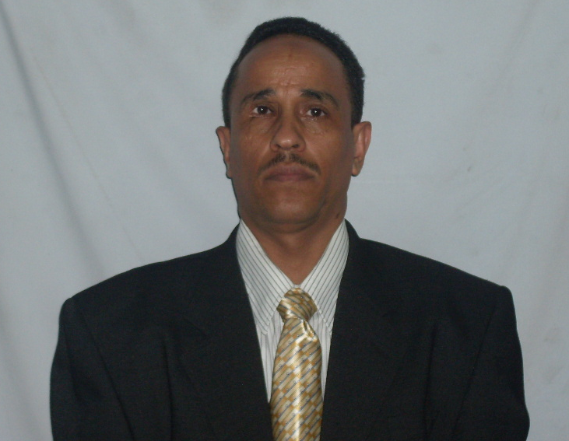
Ali Hussein Saleh Zolait is Assistant Professor of Management Information Systems and ex-Visiting Research Fellow at the University of Malaya, College of Information Technology. He holds a PhD in Management Information Systems from University of Malaya (Malaysia, 2008) and M.S in Management Information Systems from International Islamic University Malaysia IIUM Central Missouri State University (Malaysia, 2003). He has been involved for about 15 years in teaching, research, training, and/or consultancy in the areas of management information systems, technology acceptance, knowledge-based system management, computer applications, project management, spreadsheet modelling, systems analysis and design, Entrepreneurship and Innovation management science, advanced data Analysis and business research methodology. He is Editor-in-Chief of the International Journal of Technology Diffusion (IJTD), IGI Publishing, USA. He is the author of the premier reference source: Internet Banking Acceptance: Perspective of User's Informational Based Readiness, LAMBERT Academic Publishing, (Germany, 2012), 978-3-8465-9814-6. He is the author/editor of the book Knowledge and Technology Adoption, Diffusion, and Transfer: International Perspectives (2011), IGI Global, USA. Also, he is the author/editor of the book: Technology Diffusion and Adoption: Global Complexity, Global Innovations. Assistant Professor Zolait has published more than 50 research papers that have appeared in international refereed journals & conferences.

Short Bio
A. Prof. Ali Hussein Saleh Zolait
Department of Information Systems
College of Business Administration
University of Bahrain
P.O Box 32038, Sakhir, Bahrain
Mobile: (973) 39323522
Tel: (973) 1743 7702
Fax: (973) 1744 9119
Email: azolait@uob.edu.bh

Dr. Ali Hussein Saleh Zolait (Known Dr. Zolait) is the Assistant Professor of Management Information Systems (MIS) at the College of Information Technology – Department of Information System – University of Bahrain. Dr. Zolait is considered a prominent scholar and leader in the field of Innovation Diffusion and Technology Acceptance. He has published more than 50 articles on aspects of Information Security, Internet Banking, Mobile Application, Supply Chain Integration, Information Systems Performance in Organization, Web Maturity Evaluation, Information Systems, Performance Analysis and Instructional Technologies and E-commerce Application. His work has been published in leading International Journals such as Government Information Quarterly, Behaviour & Information Technology, Journal of Systems and Information Technology, Journal of Financial Services Marketing. He is the Editor-in-Chief of the International Journal of Technology Diffusion (IJTD). Before coming to University of Bahrain, he was the stoops distinguished assistant professor of E-commerce and Management Information Systems at Graduate School of Business- University of Malaya - Malaysia which is ranked one of top 100 Universities in the world. Dr. Zolait also serves as the Visiting Research at the University of Malaya at Faculty of Business and Accountancy (2008). He has excellent and International communication skills, a collegial approach to faculty and student interactions, and a sincere appreciation of cultural diversity. He literally developed hundreds of students at all level- undergraduate, MBA, MM, executive development and doctoral. Dr. Ali Zolait research papers have appeared in international refereed journals among others Government Information Quarterly, Journal of Systems and Information Technology, Behaviour & Information Technology, Journal of Financial Services Marketing, Journal of Internet Banking and Commerce, International Journal of Bank Marketing (IJBM), International Journal of Business Information Systems (IJBIS), and International Journal of E-Services and Mobile Applications. His published research is cited numerously by other authors in leading journals. Dr. Zolait served as a member of quite numbers of national, regional, and international professional associations and affiliated with Professional Societies such as the ACM, association for Information Systems (AIS) – USA, Maklumat Sains Teknologi Dan Inovasi (MASTIC)- Malaysia , Yemeni Association of Management. International Consortium for Electronic Business (ICEB) Membership, (Member ID = 000271) http://www.calpoly.edu/~eli/iceb/index.html, Member of the Resources Management Association (IRMA), International committee for the International Information Systems Conference iisc2011, 11-12 October 2011, Sultan Qaboos University, Muscat, Sultanate of Oman ,and Member of the Emerald LiteratiNetwork. Dr. Zolait is member in the Editorial Board of many International Journals among others International Journal of Principles and Applications in Information Science and Technology (PAIST) editorial board. http://www.paist.org/ , International Journal of Information Systems and Social Changes (IJISSC) editorial board. http://www.igi-pub.com/journals/details.asp?ID=7827&v=review_board, International Journal of Applied Decision Sciences (IJADS) editorial board, the Asian Journal of Business and Accounting AJBA, the Journal of the Faculty of Business and Accountancy, University of Malaya, Malaysia, International Journal of Bank Marketing (IJBM) editorial board, International Journal of Information Systems in the Service Sector editorial Board. Executive Editor: International Journal of Electronic Banking Systems, IBIMA Publishing. Moreover, Dr. Zolait is recipient of a number of local, regional, and international research awards, grants, and scholarships. He also has attended and participated in several international refereed conferences worldwide. He has served as track chair, conference gust, and reviewer in many international conferences: IMIR, APDSI, BDI, COMBI, IBIMA and GITMA.

